Chapter 2

Junction Physics and Solar Cells

Junctions in semiconductor devices
Semiconductor junctions are categorized as: i) metal/semiconductor junctions (Schottky and Ohmic), and ii) semiconductor/semiconductor junctions (homojunction and heterojunction). These four junctions are described briefly below.

Schottky junction
This junction is created when a metal contacts a semiconductor. The features and the behaviour of the junction vary depending on the electrical properties of materials (both the metal and the semiconductor). Figure ‎2.1a shows a metal and a p-type semiconductor before contact. The vacuum level is used as a reference for all other levels. The work function of the metal was assumed to be larger than that of the semiconductor (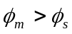). After contact (Figure ‎2.1b), Fermi levels at both sides should align with each other. To satisfy this condition, holes must flow from semiconductor to metal leaving behind them negatively charged atoms, until the Fermi levels become aligned. The charged atoms in the semiconductor side establish the depletion region. Consequently, the rest of the holes in the semiconductor side face a barrier height  preventing them from crossing the junction. For a Schottky contact with a p-type semiconductor [1]

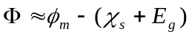 (‎2.1)

where 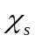 is the electron affinity of the semiconductor. An analogous description can be made for an n-type semiconductor.

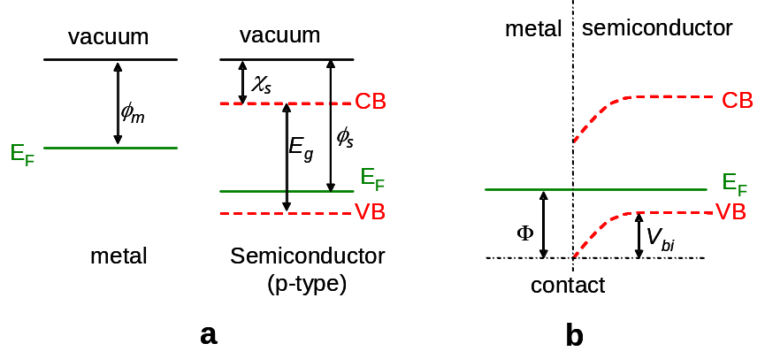

Figure ‎2.1: a) The energy band diagrams of a metal and a semiconductor before contact, b) the change in the band alignment after contact showing the resulting Schottky barrier.

Ohmic contact
For a p-type semiconductor, Ohmic contact can be created if 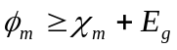[1]. The energy bands for a metal and a semiconductor describing this condition are shown in Figure ‎2.2. In Figure ‎2.2b, holes in the valence band do not face any barrier, and can transport freely.

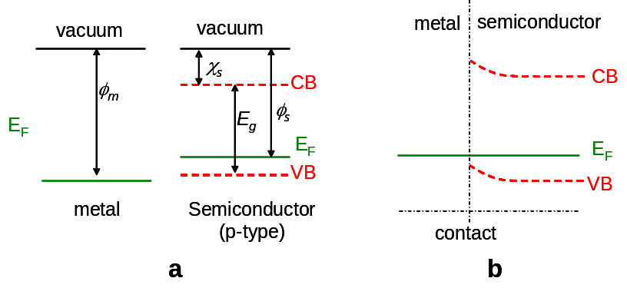

Figure ‎2.2: a) The energy band diagrams of a metal and a semiconductor before contact, b) the change in the band alignment after contact showing the resulting Ohmic contact.

Another way to make an Ohmic contact is by allowing carriers to tunnel through the barrier. A condition like that can be approached by heavily doping the semiconductor side at the interface with the metal [2]. Figure ‎2.3 shows the same barrier as Figure ‎2.1b, but with the semiconductor surface being heavily doped. This kind of contact should have the same characteristics of the Ohmic one. Back contact for CdTe cells are usually made by heavily doping the back surface before metallization. Further discussion about CdTe back contact is presented in Chapter 7.

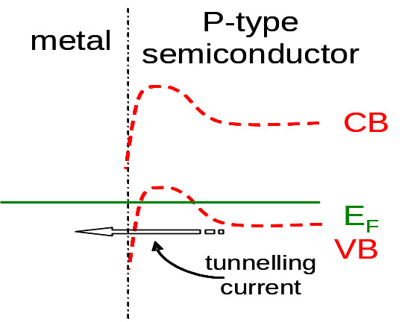

Figure ‎2.3: Changing Schottky contact to an Ohmic one by creating high density of localized states within the energy barrier.

Homojunction
Homojunctions arise from the contact between p- and n-types semiconductors under the condition that both parts are made of the same material. Usually this structure is manufactured by doping one side of the semiconductor with donors and the other side with acceptors. Since energy bands on both sides are identical, the junction does not have “energy spikes” i.e. barriers to transport.
As for other junctions, the Fermi level has to align in order to form the junction. Electrons flow from the n-type side to the p-type side leaving positively charged ions in the bulk close to the interface, and holes do exactly the opposite. Hence, a depleted part of the bulk (i.e. depletion region) is created with a built-in electric field opposing more carriers to move across as shown in Figure ‎2.4.

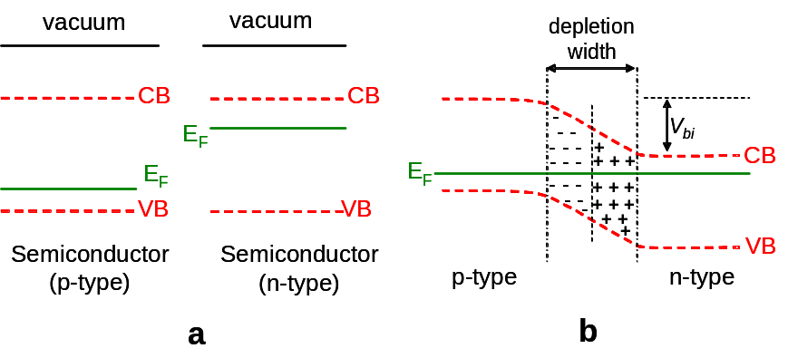

Figure ‎2.4: Semiconductor/semiconductor homojunction a) before, b) after contacting.

Heterojunction
This junction is established between p-type and n-type semiconductors as for the homojunction, however, unlike the homojunction, the two sides are not made of the same material and their energy bands are different. When the Fermi levels align, spikes in the bands can be created. Figure ‎2.5 illustrates the bands before and after contact. This junction is commonly used for solar cells fabricated with direct band gap materials.

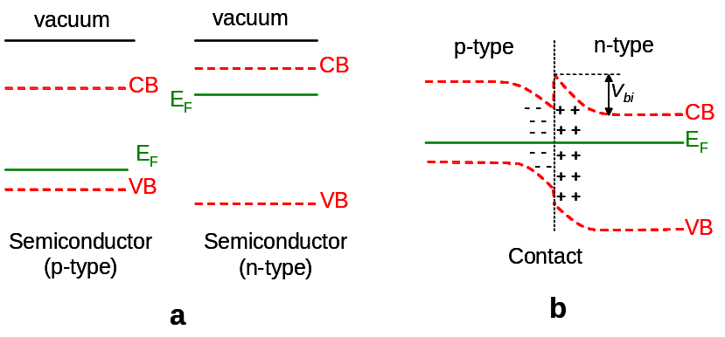

Figure ‎2.5: a) Two different semiconductors before contact, b) the heterojunction resulting from contacting the semiconductors in part a).

The energy-band diagram of heterojunction can be determined using Anderson’s rule [3, 4]. In this rule, the vacuum levels of the semiconductors in both sides are aligned before contact. However, after contact, the Fermi level should be at the same energy across both the junction and the bulk materials i.e. Fermi level is aligned. Thus, by knowing the electron affinity, the work function and the band gap of each side of the junction, both the built-in potential and the bands offsets can be calculated. The limitation of the Anderson’s rule is that it considers only ideal junctions in which there are no interface traps.

Depletion layer capacitance
Since the CdTe/CdS heterojunction is a p-n junction, only this type of junction is considered in this Section. It is mentioned in Section 2.1 that in order to align the Fermi level across the junction, majority carriers should transfer from each side to the other, which creates the depletion region. This part of the device can be assumed as a parallel-plate capacitor due to the opposite charge distribution across it.
Based on the charge distribution, the junction can be classified as: a) abrupt, where the impurity concentration change sharply from donors to acceptors or vice versa, and b) linearly graded, where the impurity concentration changes linearly across the junction.
For the abrupt junction, solving Poisson’s equation allows determination of the depletion region width (usually called depletion width) from equation 2.2 [5],

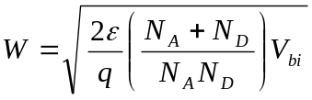 (‎2.2)

where W is the depletion width, is the dielectric constant of the material, V_{bi} is the built-in potential, q is the electronic charge and N_{A} and N_{D} are the doping concentrations in p- and n-side of the junction respectively. However, if one side of the junction is substantially more doped than the other (i.e. N_{A} >> N_{D} or vice versa) then equation 2.2 will be

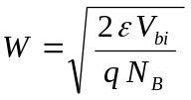 (‎2.3)

where N_{B} is the doping concentration of the lightly-doped side. This is the so-called one-sided junction. W changes with the external applied voltage V, and can be determined from

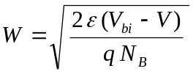 (‎2.4)

The capacitance of this junction C is defined as

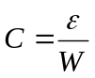 (‎2.5)

By using equations 2.4 and 2.5

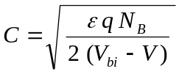 (‎2.6)

or

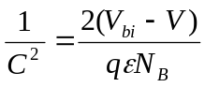 (‎2.7)

Equation 2.7 implies that both N_{B} and V_{bi} can be determined from the slope and the intercept of the line resulting from plotting 1/C² as a function of V respectively. This is usually achieved by applying variable external voltage across the junction and measure the capacitance. This kind of experiment is called C-V measurement, and it was used to analyse some samples in Chapter 6.

The diode equation
The key part of the solar cell is the device junction (e.g. Schottky, homojunction or heterojunction). The basic idea is to generate electrical carriers by absorbing the visible light in (or at least near) the junction. The generated carriers are driven by the built-in electric field within the depletion region to the external circuit. The dark current of the ideal p-n junction solar cell is described by the Shockley diode equation [6],

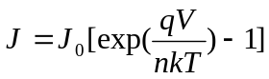 (‎2.8)

where J is the current density, J₀ is the saturation current density, q is the electronic charge, V is the applied voltage, k is Boltzmann constant, T is the temperature and n is the ideality factor (see Appendix B for the derivation of Shockley equation). The physical meaning of the ideality factor and its mathematical origin are discussed in Section 2.4 and Appendix B).
If the cell is illuminated then it will produce a light generated current J_{L} and equation 2.8 becomes

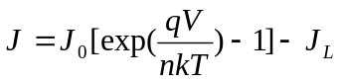 (‎2.9)

The equivalent circuit of the ideal solar cell is illustrated in Figure ‎2.6 [7].

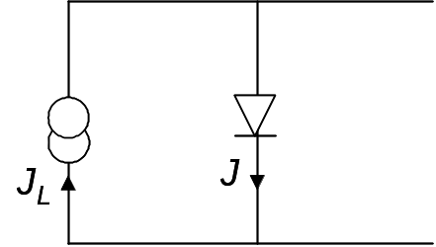

Figure ‎2.6: The equivalent circuit of the ideal solar cell.

In the actual devices there are two resistances added to the equivalent circuit as they considerably affect the PV performance of the cells. The first is the series resistance R_{s}, which is due to both the bulk material and the contacts of the device. The second is the shunt resistance R_{sh} which is due to leakage such as pinholes. Series and shunt resistances can be added to equation 2.8 to give

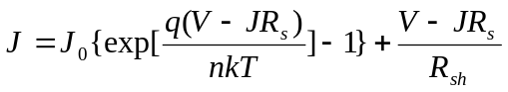 (‎2.10)

For the ideal cell 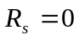 and 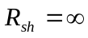which returns equation 2.10 to equation 2.8. The solar cell equivalent circuit including these resistances is shown in Figure ‎2.7. The effect of these resistances on solar cell performance is discussed in Section 2.7.

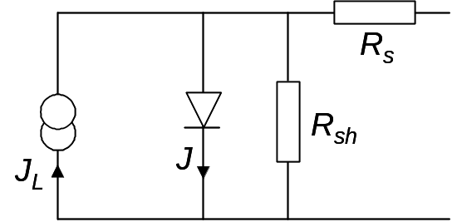

Figure ‎2.7: The equivalent circuit of the non-ideal solar cell including series and shunt resistances.

Ideality factor
This factor (sometimes called diode factor) (n), which is mentioned in equation 2.8, indicates the ideality of the junction i.e. the validity of describing the junction behaviour by the Shockley equation (equation 2.8), and should have a value of unity for the ideal junction, where diffusion dominates the current [2]. However, n will have higher values if the junction deviates from the ideal case e.g. as recombination currents start to dominate. The behaviour of this factor as a function of temperature plays an important role in determining the electrical transport mechanisms across the junctions (see Chapter 6). More details about the variation of this factor with different current transport processes are presented in Appendix B.
Many methods have been applied to determine the value of the ideality factor from experiments and some are now described.

a) Sites and Mauk method
Sites and Mauk [8] differentiated equation 2.10 and expressed it in the following from:

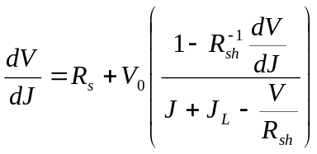 (‎2.11)

where 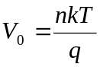 . Thus, plotting 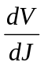 versus the value between the parentheses in equation 2.11 should yield a straight line, and the ideality factor can be extracted from the slope. In the case that R_{sh} is sufficiently large, equation 2.11 becomes

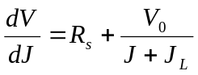 (‎2.12)

For this case, n can be calculated from the slope of versus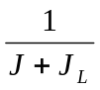. Hence in order to apply this model to real devices the values of R_{s}, R_{sh} and J_{L} must be known.

b) Quanxi and Enke method
Quanxi and Enke [9] reported measurement of n by an analytical method. They defined a straight line L expressed by the equation

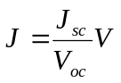 (‎2.13)

Where Jsc is the short circuit current density and Voc is the open circuit voltage, see Section 2.6 for more details about these two parameters. The intersection of L with the illuminated J-V curve is denoted as P, which therefore has the coordinate (J_{p}, V_{p}). Based on the calculations made, n can be determined for the ideal solar cells ( and ) from the equation

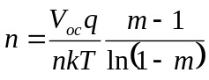 (‎2.14)

where 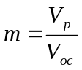. However, if either R_{s} or R_{sh} have significant values, equation 2.14 becomes more complicated. For example, if both resistances are not negligible then equation 2.14 will be

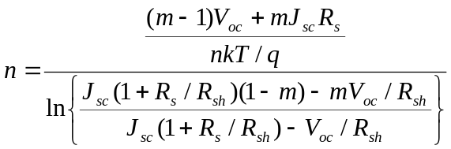 (‎2.15)

Besides the complexity of the calculation in this method, it requires the values of several parameters such as m, R_{s}, R_{sh}, J_{sc} and V_{oc}.

c) Jain and Kapoor method
This method calculates n by using Lambert W-function [10], which is a mathematical function solving transcendental equations. Equation 2.10 (after adding J_{L}) was solved as a transcendental equation, and expressed (by using Lambert W-function) for J as

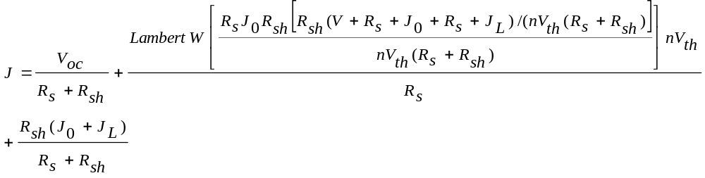 (‎2.16)

Although no approximation was made for this method, V_{oc}, R_{s}, R_{sh}, J₀ and J_{L} must be known in order to extract n by using it i.e. the inaccuracy in these values may affect the accuracy of the method itself. Moreover, this method requires a relatively long calculation in comparison to the slope method (described below) for example.

e) Rau and Schock method
Rau and Schock [11] described the current in Cu(In,Ga)Se₂ solar cells by the equation

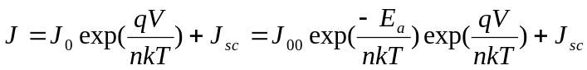 (‎2.17)

where J₀₀ is a constant and E_{a} is the activation energy. Under the open-circuit condition equation 2.17 will be

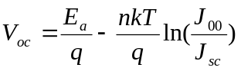 (‎2.18)

Thus, plotting V_{oc} as a function of ln J_{sc} would result in a straight line from which n is calculated. The advantage of this method is that it avoids complications from R_{s} as it has no influence under open-circuit condition.

f) Slope method
The value of n can be easily determined by using equation 2.8 (for dark measurements), where exp(qV/nkT) - 1 can be approximated as exp(qV/nkT), and the equation can be rewritten as

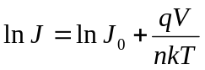 (‎2.19)

By plotting ln J versus V (for forward bias) the values of n and J₀ can be extracted from the slope and the intercept of the resultant line respectively. Equation 2.19 assumes that R_{s} and R_{sh} are negligible. This approximation is valid at only some parts of the plot.
It is seen in Figure ‎2.8 that the plot of the “ideal” diode is a straight line as expected from equation 2.19. However, if R_{s} is not negligible the line deviates from linearity. The slope from which n is extracted should be calculated from the straight part (i.e. where R_{s} has a negligible influence).

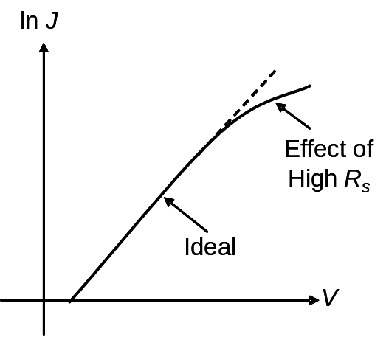

Figure ‎2.8: An example of plotting ln J versus V in the forward bias. The figure shows the effect of R_{s} on the linear behaviour of the resulted curve. The dashed line represents the difference between the ideal and the deviated curves.

The last method (f) extracts n directly from a single J-V curve without the need for values of other parameters. Bayhan [12] has calculated n by both this method and Lambert W-function, and the results extracted from both methods were in a very good agreement. For these reasons the slope method was chosen to determine n values for CdTe solar cells in the analysis undertaken in Chapter 6.
This method (i.e. the slope method) was selected to determine the ideality factor in previous studies such as [13]. Some of the methods mentioned above and others are reviewed by Bashahu and Nkundabakura [14].
The slope method can be generalised for use with light J-V data as follows: As a simplification, J_{L} can be equalised to J_{sc} [15]. Then similar to discussion for the slope method in dark, J₀ and n can be evaluated by plotting ln (J+J_{sc}) as a function of V according to equation 2.9. However, in practice the slope method did not give acceptable results when it was used to analyse the light data, as will be discussed in Chapter 7.

Some models for the electrical transport mechanisms in p-n junctions and experimental methods of identifying the mechanism

Introduction
The electrical current in p-n junction is due to the flow of the minority carriers on each side of the junction. It was mentioned in Section 2.3 that the ideal case for which Shockley equation is valid is when the current is governed by diffusion i.e. n = 1. However, in some cases, recombination of the carriers contribute to the current, which affects the value of the ideality factor i.e. 1 < n < 2.
The recombination current is defined as the current originating from the flow of carries (both electrons and holes) that recombine in the depletion region [16]. Therefore, recombination may be considered to contribute to the current transport in the p-n junction. This process may happen via direct recombination (i.e. band-to-band) or indirect recombination (i.e. when the localised states within the band gap participate in the process) [5].
Besides the processes mentioned above, there are a number of transport processes describing the flow of current though both the bulk and the junction of the p-n junction, which are collectively referred to as electrical transport mechanisms. Only mechanisms which were observed in this work will be described in detail in the following sections.
In order to determine the electrical transport mechanisms operating in semiconductor junctions by experiment, a family of J-V curves should be recorded at different temperatures i.e. J-V-T. The method is to investigate the behaviour of the slope of the J-V curves, the saturation current and the ideality factor as functions of T, and then diagnose the carrier flow mechanisms [8, 17-21]. Details follow in the descriptions of current transport mechanisms that follow.
Further to this, a novel method of determining the ideality factor (and therefore the transport mechanism) from light J-V data is presented. It has the feature that the absolute intensity of the incident light need not to be known, allowing the method to be applied easily in the laboratory using filters.

Multi-step tunnelling
This model has been proposed by Riben and Feucht in 1966 [22]. It was developed from a transport model describing direct carriers tunnelling (i.e. band to band) combined with recombination for the n-Ge/p-GaAs heterojunction [23]. Traps were assumed to be uniformly distributed in the energy gap through which carriers tunnel prior to recombination.
In this model electrons tunnel from the conduction band of the n-side (in a p-n junction) to the close localised states in the energy gap. Next, electrons continue tunnelling in a staircase path among the states where they recombine with holes eventually. A schematic diagram of this mechanism across a p-n junction is illustrated in Figure ‎2.9.

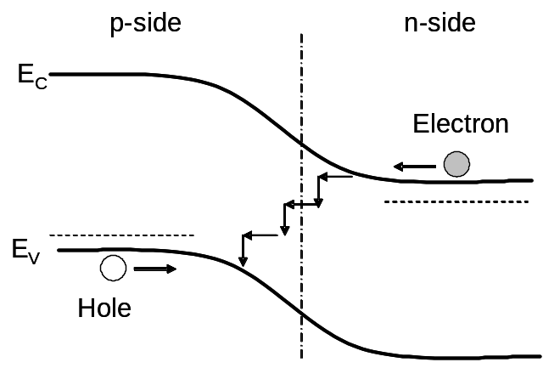
Figure ‎2.9: A schematic diagram of a p-n junction demonstrating carriers paths which are proposed in the multi-step tunnelling model, where E_{c} and E_{v} are the conduction and the valence bands respectively.

a) Forward bias behaviour
If the electrical transport mechanism is governed by this model in the p-n junction, then its forward current J_{f} is expressed as [17, 24]:

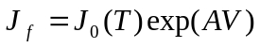 (‎2.20)

with

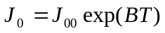 (‎2.21)

where A is the slope of lnJ versus V, J₀ is the saturation current, V is the applied voltage and B and J₀₀ are constants. The behaviour of A as a function of T may be used to identify situations in which the multi-step tunnelling mechanism is operating: Typically A is independent of T [6]. However, in practice, the experimental values of A were reported to vary slightly with T [24-26]. The characteristic behaviours of both A beside J₀ (as equation 2.21 implies) with T were used to evidence that some samples in Chapter 6 obeyed this model.
Another use of A is that it can be used to determine the number of tunnelling steps (R) required for carriers to pass the depletion region by using the following equation [27]:

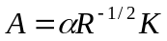 (‎2.22)

where,

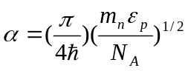, (‎2.23)

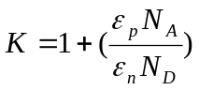, (‎2.24)

and m_{n} is the electron effective mass, 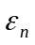 and 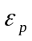 are the dielectric constants of the n- and the p-side of the junction respectively and N_{A} and N_{D} are the doping concentration of acceptors and donors respectively.

b) Reverse bias behaviour
The reverse current depends on the applied voltage according to the equation [24],

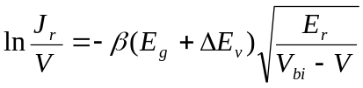 (‎2.25)

where J_{r} is the reverse current density, V is the applied voltage, V_{bi} is the built-in potential, E_{g} is band gap, 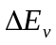 is the valence band offset, E_{r} is the barrier height for one tunnelling step and β the number of steps required for tunnelling under reverse bias conditions. The trap density required for tunnelling (N_{t}) can be calculated from the equation [28]

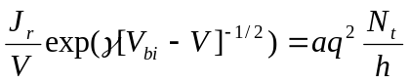 (‎2.26)

Where is a constant, a is the lattice constant, h is Planck’s constant. Equation 2.26 can be rearranged as

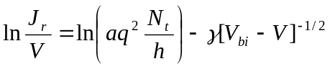 (‎2.27)

This equation implies that when multi-step tunnelling process dominates the reverse current, plotting ln (J_{r}/V) against (V_{d} - V)^{-1/2} should give a straight line with a negative slope. The intercept of this line can be used to extract N_{t}.
In general, the power dependence of J_{r} on V is evaluated by measuring m from the equation

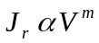 (‎2.28)

The value of m is determined from lnJ vs. lnV plot. It has been reported that m decreases as T increases when the J_{r} flow obeys multi-step tunnelling model in both CdTe/CdS and CdTe/ITO solar cells [28, 29]. When observed, this behaviour is therefore an evidence that multi-step tunnelling process is dominant for reverse current.

Shockley-Read-Hall recombination (SRH)
This model describes recombination which takes place via the localized levels (i.e. recombination centres) within the energy band gap rather than band-to-band recombination. It was proposed and discussed by Shockley and Read [30] and also by Hall [31]. SRH is a non-radiative recombination process i.e. it involves neither emission of photons (radiative) nor electrons (Auger).
The recombination centres capture carriers from both the conduction and the valence bands. There are two possibilities for a trapped carrier: a) it gains sufficient energy by thermal activation and, as a result, releases itself, or b) the trap captures another carrier with opposite polarity, then these two carriers recombine in the trap which therefore becomes empty.
For a single trap there are four possible processes (for an acceptor type trap i.e. the trap is neutral when it does not contain an electron) as shown in Figure ‎2.10:
i) Capture of an electron from the conduction band to the trap (Figure ‎2.10a),
ii) Emission of an electron from the trap to the conduction band (Figure ‎2.10b),
iii) Capture of a hole from the valence band to the trap that contain an electron i.e. emission of an electron from the trap to the valence band (Figure ‎2.10c),
iv) Emission of a hole from a trap (neutral) to the valence i.e. capture of an electron from the valence band to the trap (Figure ‎2.10d).
This model is well known and has been discussed in detail in many text books such as [2, 7, 32].

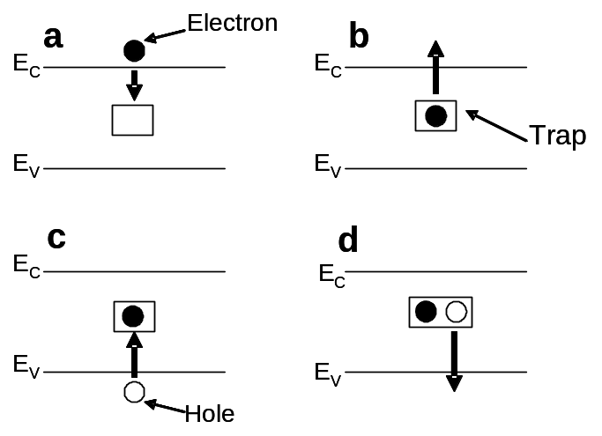
Figure ‎2.10: The four possible processes for recombination described by SRH model for a single trap. a) electron capture, b) electron emission, c) hole capture and d) hole emission.

Mitchell et al. [33] reported that the ideal value for the diode factor (n) is 2 when recombination processes in depletion region dominates the current transport in the heterojunction. This value of n occurs when carriers recombine via traps localised near the middle of the band gap (i.e. trap energy ~E_{g}/2), for which the recombination probability is maximum (see Appendix B for more details). For this case, the current can be described by equation 2.8

(2.8)

where

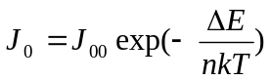 (‎2.29)

and J₀₀ is a constant and ΔE is the activation energy, which is related to the built-in potential V_{bi} by the equation

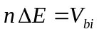 (‎2.30)

Experimental determination of the recombination mechanism from illuminated J-V data
The recombination mechanisms may be identified from the characteristic J-V-T behaviour expected for SRH, Auger and radiative recombination dominated transport. For example multi-step tunnelling conforms to equation 2.20 (under forward bias) and A is independent of T, as discussed in Section 2.5.2. In addition, the value of the diode factor n is an indicator of the mechanism. For the case of illuminated diodes, n may be evaluated by examining the behaviour of V_{oc}(T) as follows:-

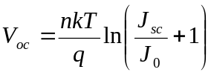 (‎2.31)

where J_{sc} was substituted by J_{L} in equation 2.31 as an approximation [15] (see Section 2.6 for further discussion of this equation). J_{sc} is linearly proportional to the light intensity [7], and then it can be written

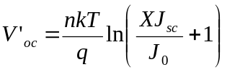 (‎2.32)

where X is the light intensity and V'_{oc} is the open-circuit voltage corresponding to this light intensity. Since J_{sc} >> J₀, equation 2.32 can be rearranged to be

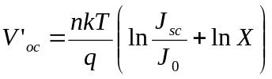 (‎2.33)

Or by using equation 2.31

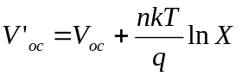 (‎2.34)

This analysis suggests an alternative methodology using a variable light intensity that has been devised and used in this work: It is assumed that measurements are taken under for example two intensities aX and bX, where the intensity ratio is known from the neutral density filters used in experiment, and the absolute intensity of the source (X) is constant. From this:-

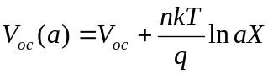 (‎2.35)

and

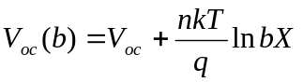 (‎2.36)

By subtracting equations 2.36 from 2.35:

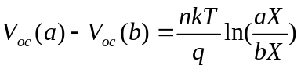 (‎2.37)

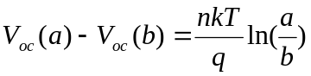 (‎2.38)

Equation 2.38 therefore eliminates the absolute intensity of the incident light.
V_{oc} varies as 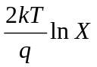, 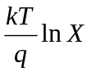 and 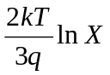for Shockley-Read-Hall (SRH), radiative and Auger processes respectively [7], where k is Boltzmann constant, T is temperature, q is electronic charge and X is the absolute intensity of the light source. Therefore, using equation 2.38, the ideality factor can be determined from the slope of the line resulting from the plot of 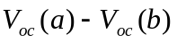 against 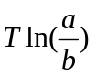. According to the discussion above, if n = 2, 1 or 2/3 then the dominant process is SRH, radiative or Auger respectively.
Table ‎2.1 summarises the equations describing the relation between J and V for seven different transport mechanisms. In addition, it shows the characteristics of each mechanism by which it may be identified.

Current transport mechanism | Equation | Diagnostic
Diffusion (no recombination) | J₀ is the saturation current | n =1  ln J₀  -1/T
Recombination in depletion region | , | n =2  ln J₀  -1/T
Multi-step tunnelling (forward bias) | , | 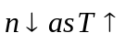  A independent of T  ln J₀  T
Multi-step tunnelling (reverse bias) |  | ln(J_{r}/V)  -(V_{d} - V)^{-1/2}  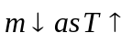
SRH recombination |  | n =2
Auger recombination |  | n =2/3
Radiative recombination |  | n =1

Table ‎2.1: Current transport mechanisms considered in this work. The table shows a) the equations describing each mechanism, and b) the diagnostic characteristics used to identify the transport mechanism. See text above for the meaning of the symbols shown.

J-V characteristics and parameters of solar cells
Solar cell performance is typically tested by applying an external voltage across the cell and measuring the current passing though it i.e. the J-V characteristics. This test can be carried out in dark or under illumination to extract important data by which the performance of the cell is evaluated. Equations 2.8 and 2.9 predict the dark and the light J-V characteristics respectively for the p-n junction solar cell, and they are illustrated in Figure ‎2.11. Ideally, the light curve should be identical to the dark one except that it is shifted downward by an amount equals to I_{L}. This condition is called the superposition principle.

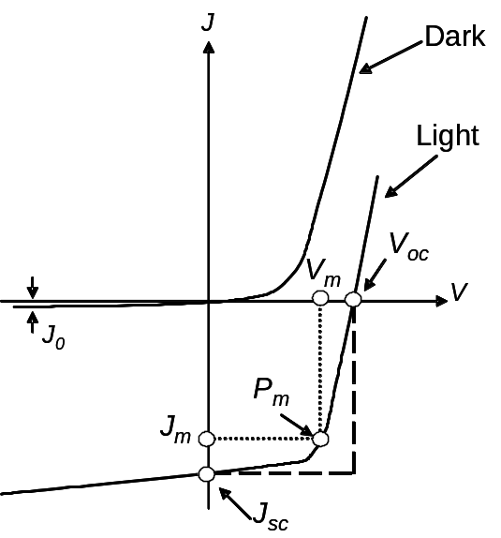

Figure ‎2.11: The dark and light J-V curves for the ideal solar cell.

There are four basic parameters to test the performance of the cells. Firstly, the open circuit voltage, V_{oc}, which is defined as the voltage between the cell terminals (contacts) when they are isolated i.e. the voltage when no current flows in the external circuit. Applying this definition to equation 2.9, V_{oc} is expressed as mentioned in equation 2.31 (Section 2.5.4) as

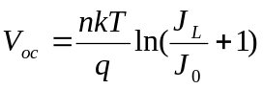 (2.31)

Figure ‎2.11 shows that V_{oc} is determined from the intercept of the light J-V curve with the voltage axis (i.e. when J = 0).
V_{oc} is related to V_{bi} according to the equation, [34]:

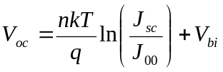 (‎2.39)

The built-in potential V_{bi} of the main junction, therefore, can be evaluated by plotting V_{oc} versus T: Equation 2.39 implies that plotting V_{oc} against T should give a straight line, which its intercept with the V_{oc} axis (at T = 0) gives the built-in potential V_{bi}.
The current density of the illuminated cell with directly connected terminals (no external voltage is applied) is called the short circuit current density J_{sc}, which is the second basic parameter for solar cells. It is the intercept of the light J-V curve with the current density axis as shown in Figure ‎2.11. Usually in calculations, this value substitutes the light-generated current I_{L} as a valid approximation [15].
The third parameter is called the fill factor, FF. It measures the coincidence of the maximum power point P_{m} with the value of multiplying V_{oc} by J_{sc}.

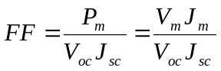 (‎2.40)

where V_{m} and J_{m} are the voltage and the current density corresponding to P_{m}. From Figure ‎2.11, FF can be expressed as the ratio between the rectangular defined by the dotted lines to the rectangular defined by the dashed lines. The maximum value of the FF is 100 % which means that the J-V curve is a perfect rectangular at the fourth quarter of the J-V plot.
The last parameter is the conversion efficiency (usually called efficiency), η. It evaluates the ratio between the maximum power generated by the cell to the power of the incident light P_{s}. AM1.5 spectrum (which results in P_{s} = 1000 W/m²) is the typical spectrum under which η is measured. Therefore, the efficiency is expressed as

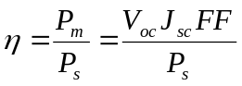 (‎2.41)

Losses in the conversion efficiency
The conversion efficiency for solar cells depends on several factors, for example, high ambient temperature has a deleterious effect on the performance of solar cells. Increasing the temperature would increase J₀ exponentially. This results in a considerable decrease in both V_{oc} and FF [6]. Therefore, the efficiency of the cell is significantly reduced as temperature increases.
Additionally, the intrinsic properties of the materials used to fabricate solar cells can create more losses. Two of these properties are discussed briefly below.

Losses due to the band gap

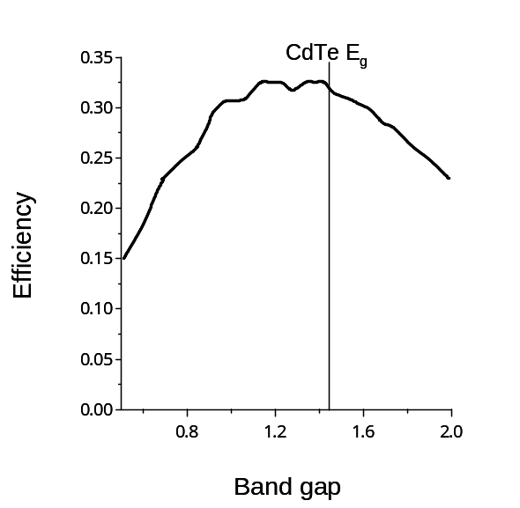

Figure ‎2.12: The theoretical conversion efficiency of single-junction solar cells as a function of the band gap E_{g}.

Since the energy conversion for solar cells relies on light absorption, the band gap of the absorber layer in the cells has a crucial effect on the efficiency. Low E_{g} allows more photons to be absorbed from light spectrum. However, the maximum possible value of V_{oc} cannot exceed E_{g} of the absorber layer. Lower value of the band gap would produce higher current but lower voltage. In contrast, using a semiconductor with relatively high E_{g} would result in generating high voltage but low current. It is a trade off between V_{oc} and J_{sc} in order to generate the maximum available power. The maximum theoretical value of the efficiency was calculated as a function of E_{g} as illustrated in Figure ‎2.12 [7]. The highest possible power that would be generated using solar cells requires a material with E_{g} ~ 1.5 eV. This value is close to the band gap of the CdTe as shown in the same figure.

Parasitic resistances
The two resistances mentioned in Section 2.3 (R_{s} and R_{sh}) are called the parasitic resistances as they affect the performance of the solar cell. R_{s} is a common issue for solar cells especially at high voltages where its effect is more pronounced as shown Figure ‎2.8. Both resistances, R_{s} and R_{sh}, can significantly influence the efficiency of the cells. As seen in Figure ‎2.13a and Figure ‎2.13b, the parasitic resistances change the J-V curves of illuminated cells. The obvious effect of them (from the figure) is reducing FF, and therefore the efficiency. However, high R_{s} and low R_{sh} might reduce J_{sc} and V_{oc}, respectively [7]. It is worth mentioning again that the ideal case for solar cells is to have and.

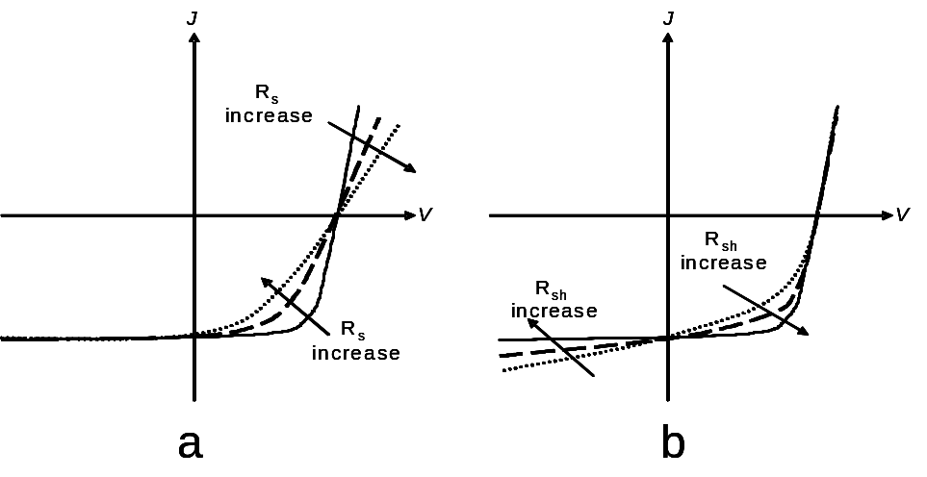

Figure ‎2.13: The effect of R_{s} and R_{sh} on the illuminated J-V curves of solar cells are shown in figures a and b respectively.

References for Chapter 2

[1] A. W. Brinkman. in (P. Capper, Ed.) Properties of Narrow Gap Cadmium-based Compounds, INSPEC, the institution of Electrical Engineers, London (1994).
[2] S. M. Sze, Physics of Semiconductor Devices, 2nd ed., A Wiley-Interscience Publication, New Jersey, (1981).
[3] R. L. Anderson, Solid-State Electronics 5 (1962) 341-351.
[4] R. L. Anderson, IBM J. Res. Dev. 4 (1960) 283-287.
[5] S. M. Sze, Semiconductor Devices Physics and Technology, John Wiley & Sons, New York, (1985).
[6] A. L. Fahrenbruch and R. H. Bube, Fundamentals of Solar Cells, 1st ed., Academic Press, London, (1983).
[7] J. Nelson, The Physics of Solar Cells, 2nd ed., Imperial College Press, London, (2003).
[8] J. R. Sites and P. H. Mauk, Solar Cells 27 (1989) 411-417.
[9] J. Quanxi and L. Enke, Solar Cells 22 (1987) 15-21.
[10] A. Jain and A. Kapoor, Solar Energy Materials and Solar Cells 85 (2005) 391-396.
[11] U. Rau and H. W. Schock, Applied Physics A: Materials Science & Processing 69 (1999) 131–147.
[12] H. Bayhan, Solar Energy 83 (2009) 372-376.
[13] A. A. Alnajjar, M. F. A. Alias, R. A. Almatuk and A. A. J. Al-Douri, Renewable Energy 34 (2009) 2160-2163.
[14] M. Bashahu and P. Nkundabakura, Solar Energy 81 (2007) 856-863.
[15] G. Zoppi, PhD Thesis, Durham University, Durham, (2005).
[16] D. A. Neamen, Semiconductor Physics and Devices Basic Principles, 3rd ed., McGraw-Hill, New York, USA, (2003).
[17] R. H. Bube, Solar Cells 23 (1988) 1-17.
[18] D. Johnstone, T. D. Golding, R. Hellmer, J. H. Dinan and M. Carmody, Journal of Electronic Materials 36 832-836.
[19] Z. Djebbour, A. M. Dubois, A. Darga, D. Mencaraglia, C. Bazin, J. P. Connolly, J. F. Guillemoles, D. Lincot, B. Canava and A. Etcheberry, Thin Solid Films 515 (2007) 6233-6237.
[20] J. Tan and W. A. Anderson, Solar Energy Materials and Solar Cells 77 (2003) 283-292.
[21] S. S. Hegedus and W. N. Shafarman, Progress in Photovoltaics: Research and Applications 12 (2004) 155-176.
[22] A. R. Riben and D. L. Feucht, International Journal of Electronics 19 (1965) 583.
[23] A. R. Riben and D. L. Feucht, Solid-State Electronics 9 1055-1065.
[24] S. S. Ou, O. M. Stafsudd and B. M. Basol, Solid-State Electronics 27 (1984) 21-25.
[25] M. El Yacoubi, R. Evrard, N. D Nguyen and M. Schmeits, Semiconductor Science and Technology 15 (2000) 341-348.
[26] H. Bayhan and C. Ercelebi, Semiconductor Science and Technology 12 (1997) 600-608.
[27] H. M. Al-Allak, A. W. Brinkman, H. Richter and D. Bonnet, Journal of Crystal Growth 159 (1996) 910-915.
[28] S. Vatavu and P. GaSin, Thin Solid Films 515 (2007) 6179-6183.
[29] H. Yakubu, Renewable Energy 17 (1999) 61-71.
[30] W. Shockley and W. T. Read, Physical Review 87 (1952) 835-842.
[31] R. N. Hall, Physical Review 87 (1952) 387 - 387.
[32] C. T. Sah, Fundamentals of Solid-State Electronics, 8th ed., World Scientific Publishing Co. Pte. Ltd. (1991).
[33] K. W. Mitchell, Evaluation of the CdS/CdTe Heterojunction Solar Cell, Garland Publishing, Inc., New York, (1979).
[34] K. W. Mitchell, A. L. Fahrenbruch and R. H. Bube, Journal of Applied Physics 48 (1977) 4365-4371.

